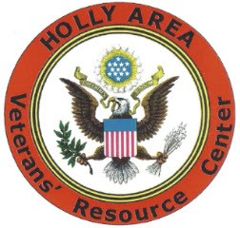
HOLLY AREA VETERANS RESOURCE CENTER’S
MONTHLY VET-TO-VET DINNER MOVED

The Holly Area Veterans Resource Center has moved its monthly Vet-To-Vet dinner on November 18, 2024, to the Holly Veterans of Foreign Wars Post 5587 because of the heavy tornado damage to the American Legion Post 149. VFW 5587 is located at 201 Airport Dr, Holly MI, 48442.
The Vet-to-Vet dinner will start at 5:30pm. The dinner is free and open to all veterans and their families. If you would like to bring a dish to pass, that would be great. The speaker is Rylee Whitman from PNC Bank. Rylee will be talking about all the scams out there that affect seniors and how to avoid them.
Katrina Gramer, HARVC Service officer will be present to answer questions.
Holly Area Veterans Resource Center is in a new location. We are at 1006 N. Saginaw St., Holly MI, 48442. Visit us at our new offices. Katrina Gramer our Service Officer is located in our new offices.
For more information call Joe Mishler at 810-348-9960

__
11/12/2024, Contact Joe MIshler

